Test Case: tc002_SPX_Dev5_Crear_Requisicion_Spot_Con_FAD_Tipo_Cobro_CC
Step 1 - Enter username and password and click to button Enter : Credentials Entered
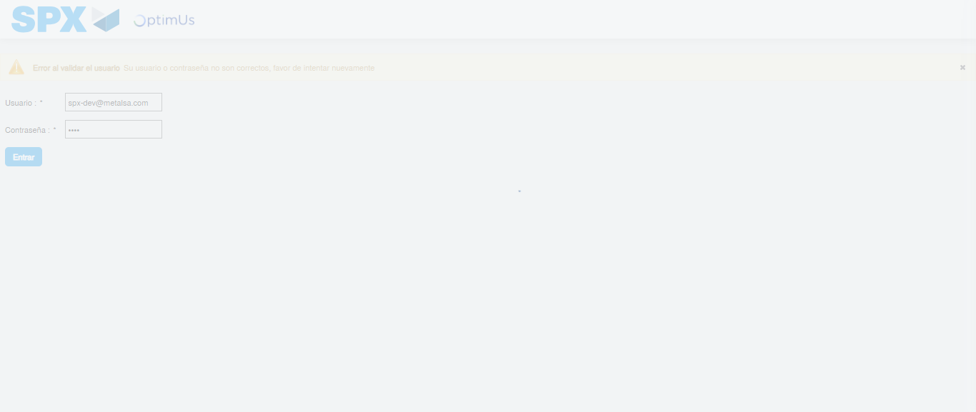Image file-name: QC_Testing-tc002_SPX_Dev5_Crear_Requisicion_Spot_Con_FAD_Tipo_Cobro_CC-1783355184790

Step 2 - Select to UEN and Access to Spot Buy Requisitions : UEN Correctly selected and Correct access
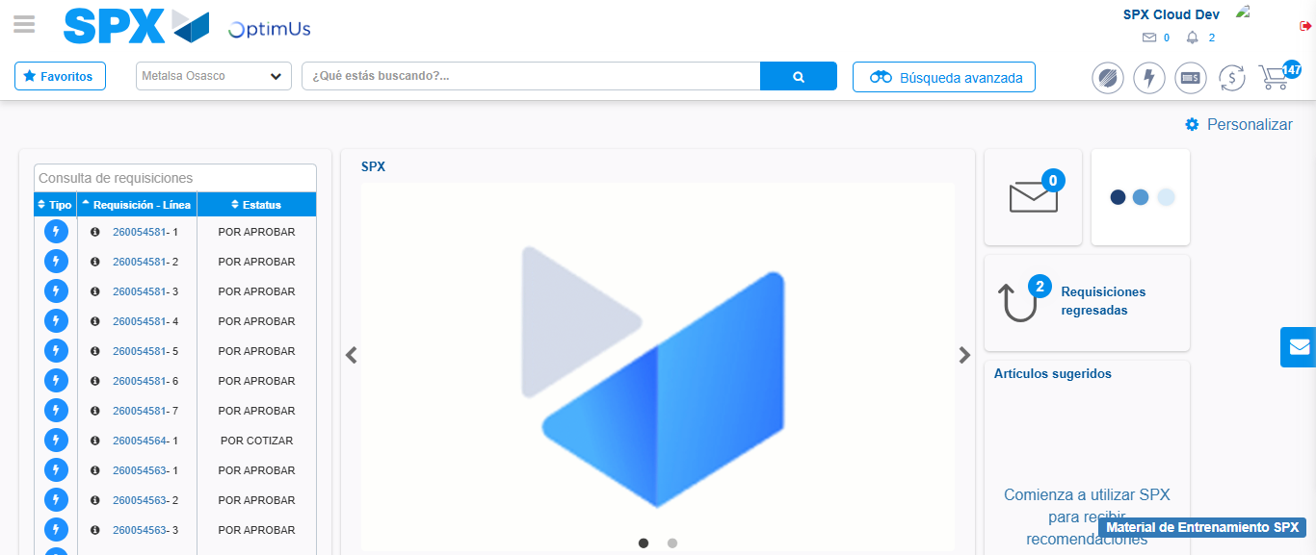Image file-name: QC_Testing-tc002_SPX_Dev5_Crear_Requisicion_Spot_Con_FAD_Tipo_Cobro_CC-1783355210140

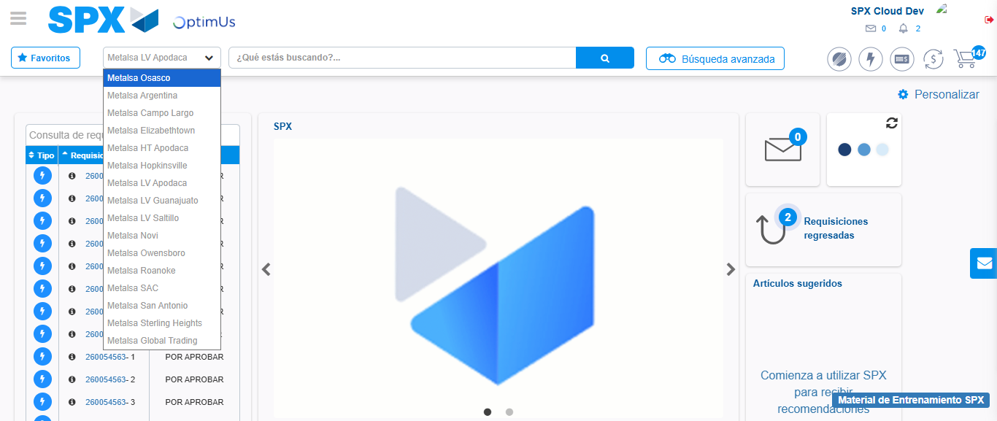Image file-name: QC_Testing-tc002_SPX_Dev5_Crear_Requisicion_Spot_Con_FAD_Tipo_Cobro_CC-1783355212767

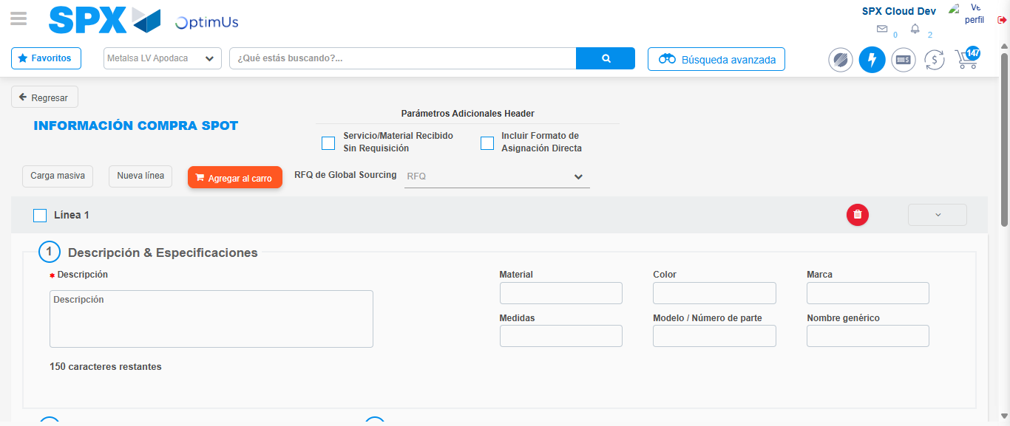Image file-name: QC_Testing-tc002_SPX_Dev5_Crear_Requisicion_Spot_Con_FAD_Tipo_Cobro_CC-1783355234970

Step 3 - Add FAD to Requisition: FAD Successfully Added
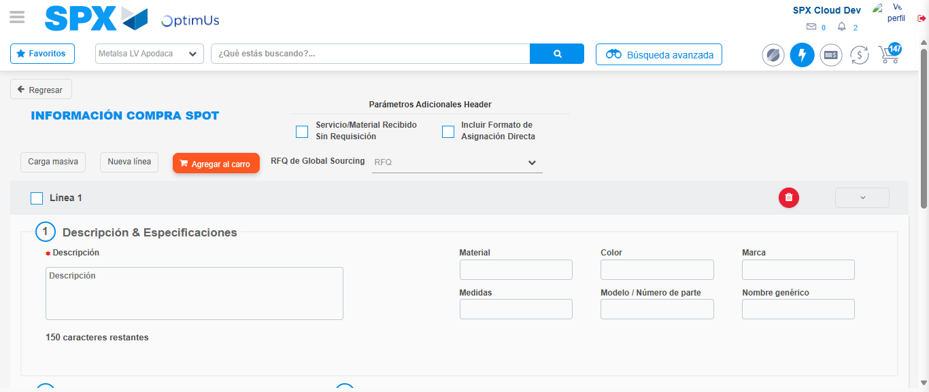Image file-name: QC_Testing-tc002_SPX_Dev5_Crear_Requisicion_Spot_Con_FAD_Tipo_Cobro_CC-1783355235264

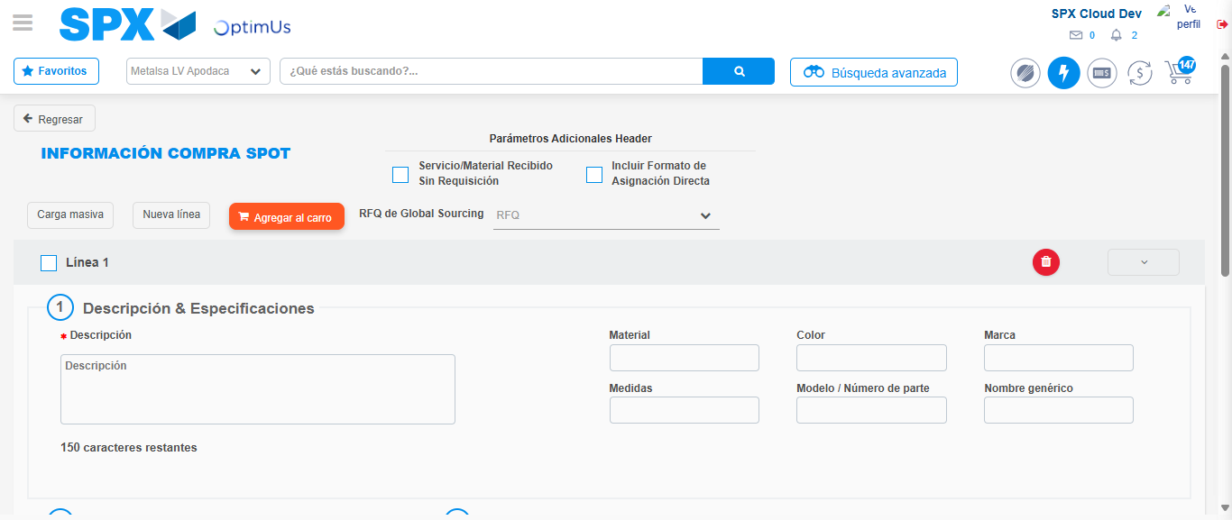Image file-name: QC_Testing-tc002_SPX_Dev5_Crear_Requisicion_Spot_Con_FAD_Tipo_Cobro_CC-1783355235485

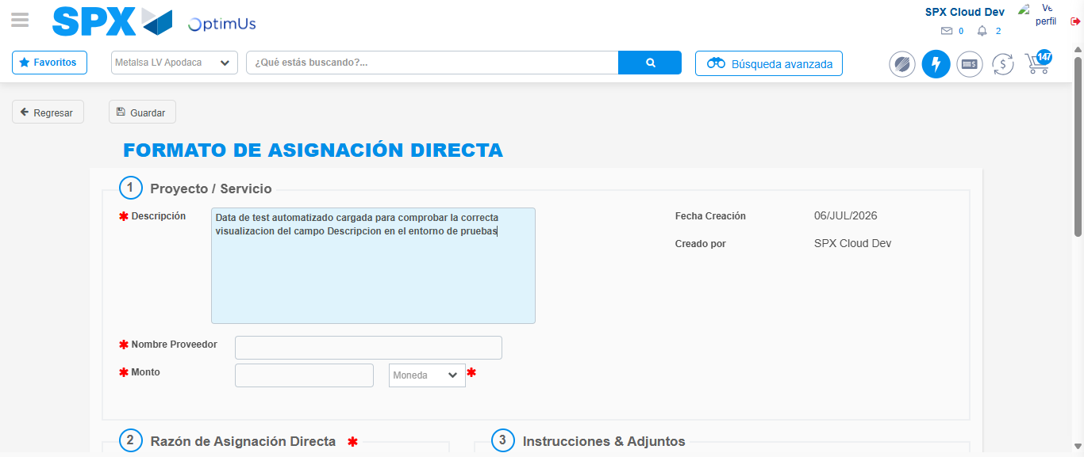Image file-name: QC_Testing-tc002_SPX_Dev5_Crear_Requisicion_Spot_Con_FAD_Tipo_Cobro_CC-1783355238211

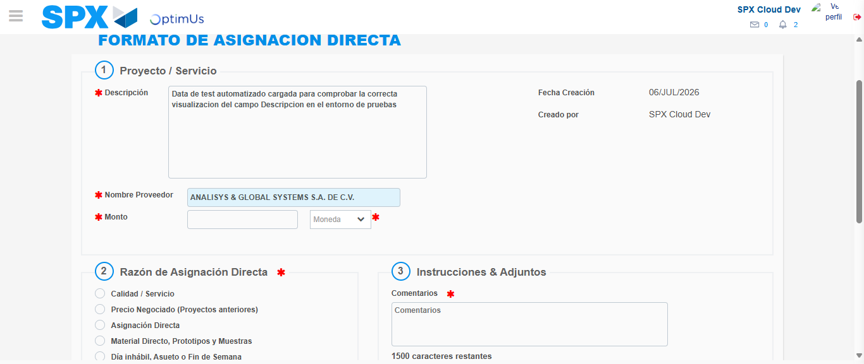Image file-name: QC_Testing-tc002_SPX_Dev5_Crear_Requisicion_Spot_Con_FAD_Tipo_Cobro_CC-1783355244240

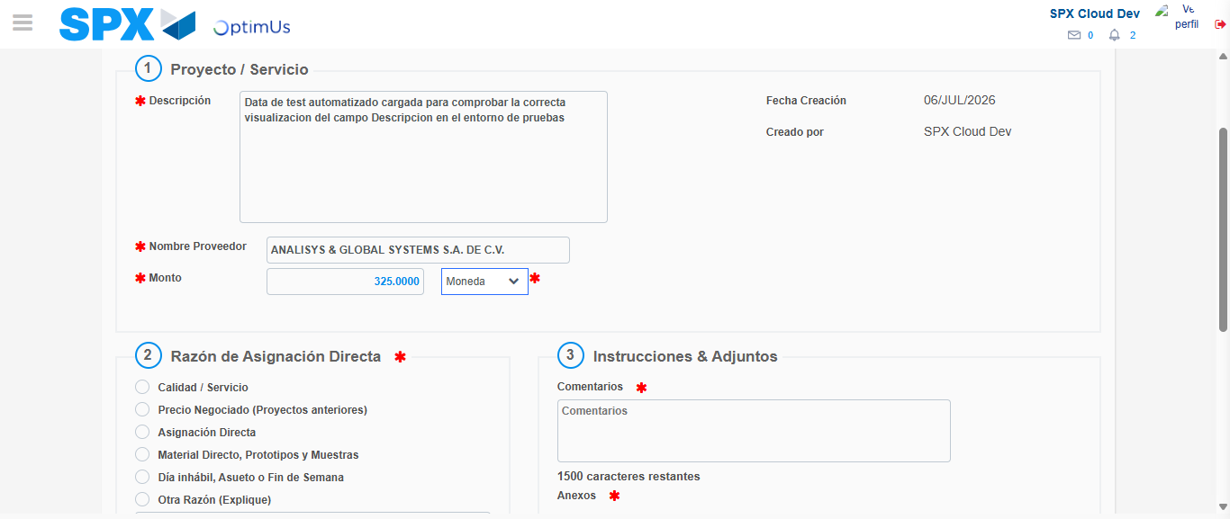Image file-name: QC_Testing-tc002_SPX_Dev5_Crear_Requisicion_Spot_Con_FAD_Tipo_Cobro_CC-1783355244664

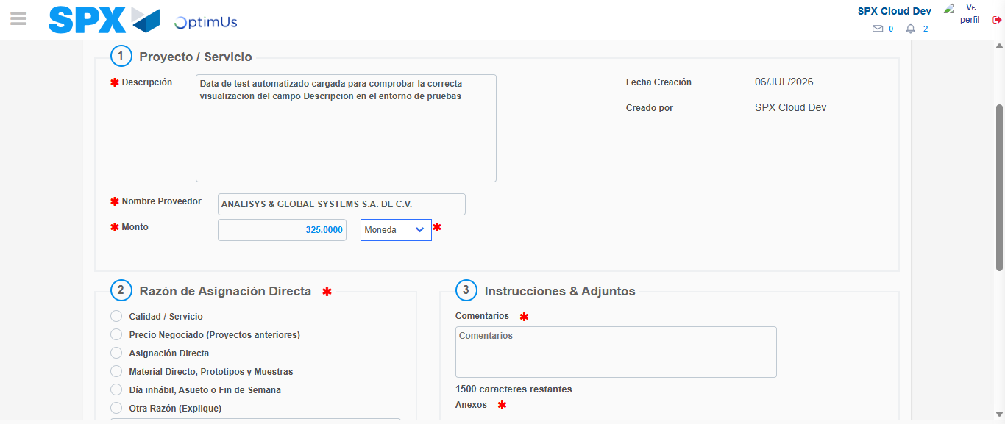Image file-name: QC_Testing-tc002_SPX_Dev5_Crear_Requisicion_Spot_Con_FAD_Tipo_Cobro_CC-1783355244852

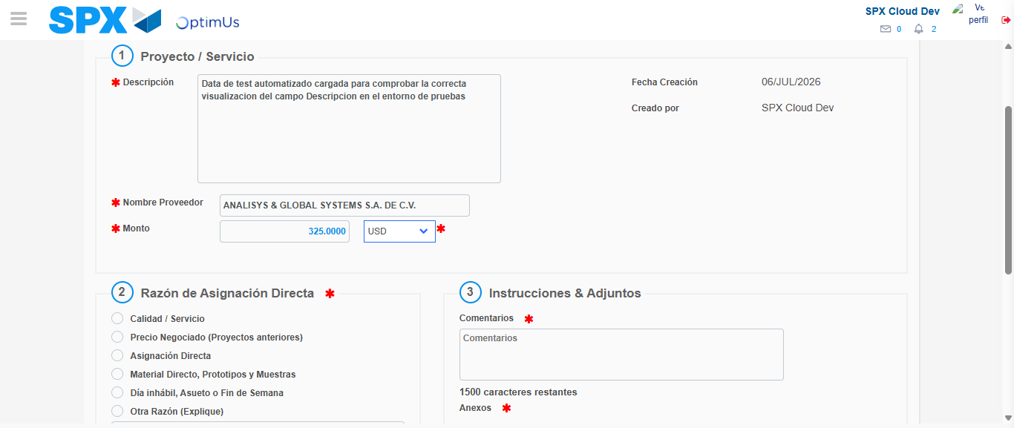Image file-name: QC_Testing-tc002_SPX_Dev5_Crear_Requisicion_Spot_Con_FAD_Tipo_Cobro_CC-1783355245233

Image file-name: QC_Testing-tc002_SPX_Dev5_Crear_Requisicion_Spot_Con_FAD_Tipo_Cobro_CC-1783355245448

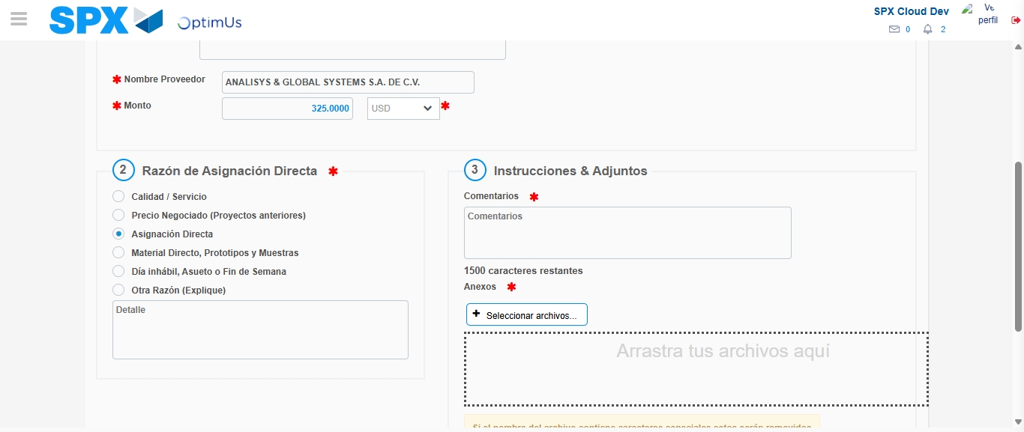Image file-name: QC_Testing-tc002_SPX_Dev5_Crear_Requisicion_Spot_Con_FAD_Tipo_Cobro_CC-1783355246239

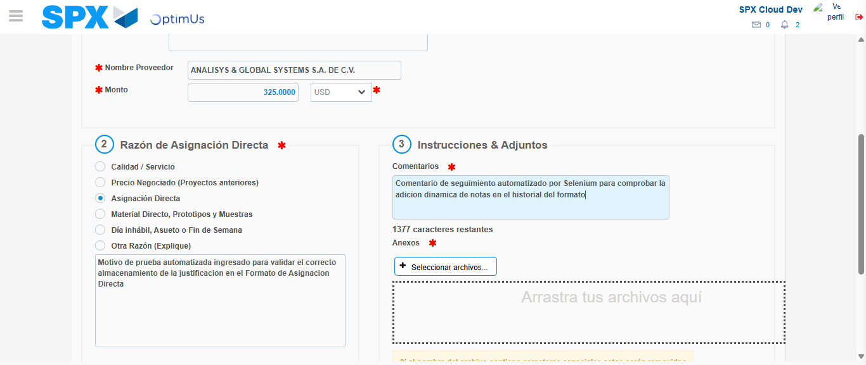Image file-name: QC_Testing-tc002_SPX_Dev5_Crear_Requisicion_Spot_Con_FAD_Tipo_Cobro_CC-1783355257339

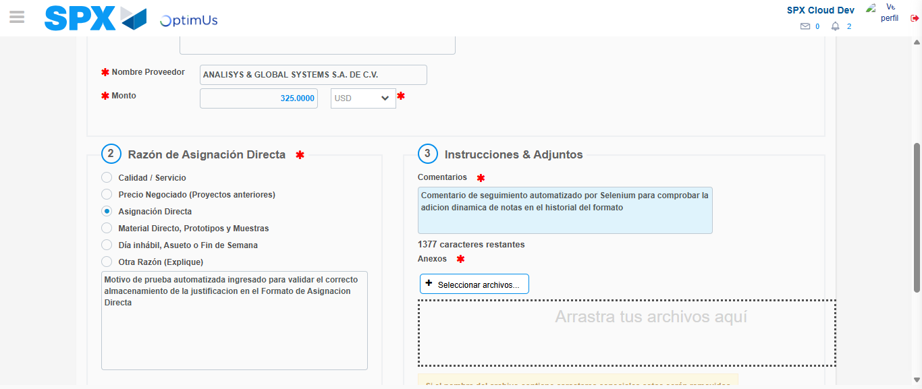Image file-name: QC_Testing-tc002_SPX_Dev5_Crear_Requisicion_Spot_Con_FAD_Tipo_Cobro_CC-1783355258049

Step 4 - Data Capture Spot Buy Requisition: Data captured correctly
Image file-name: QC_Testing-tc002_SPX_Dev5_Crear_Requisicion_Spot_Con_FAD_Tipo_Cobro_CC-1783355235264

Image file-name: QC_Testing-tc002_SPX_Dev5_Crear_Requisicion_Spot_Con_FAD_Tipo_Cobro_CC-1783355235485

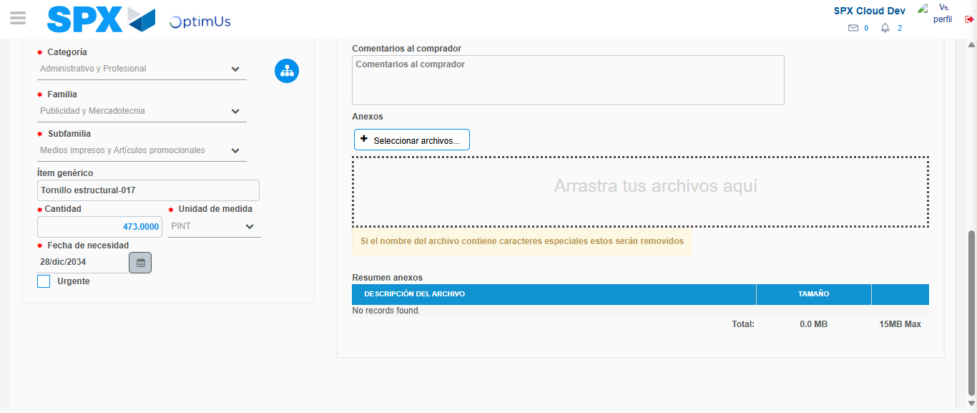Image file-name: QC_Testing-tc002_SPX_Dev5_Crear_Requisicion_Spot_Con_FAD_Tipo_Cobro_CC-1783355270901

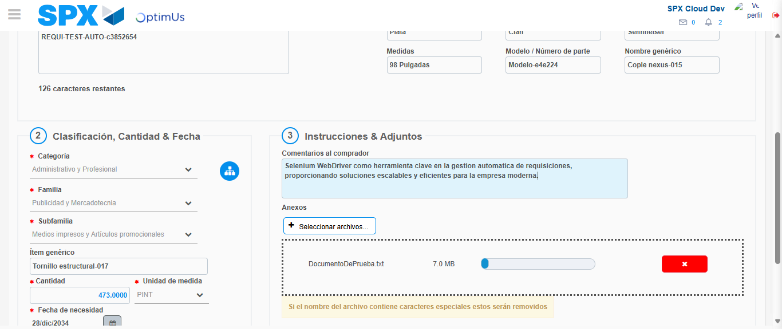Image file-name: QC_Testing-tc002_SPX_Dev5_Crear_Requisicion_Spot_Con_FAD_Tipo_Cobro_CC-1783355271700

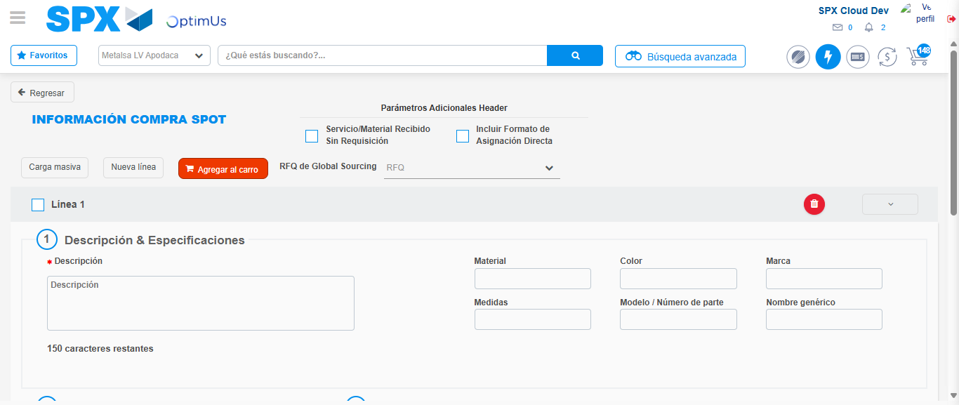Image file-name: QC_Testing-tc002_SPX_Dev5_Crear_Requisicion_Spot_Con_FAD_Tipo_Cobro_CC-1783355276771

Step 8 - Return to Main Page SPX : Return to Main Page SPX
Image file-name: QC_Testing-tc002_SPX_Dev5_Crear_Requisicion_Spot_Con_FAD_Tipo_Cobro_CC-1783355210140

Image file-name: QC_Testing-tc002_SPX_Dev5_Crear_Requisicion_Spot_Con_FAD_Tipo_Cobro_CC-1783355212767

Image file-name: QC_Testing-tc002_SPX_Dev5_Crear_Requisicion_Spot_Con_FAD_Tipo_Cobro_CC-1783355234970

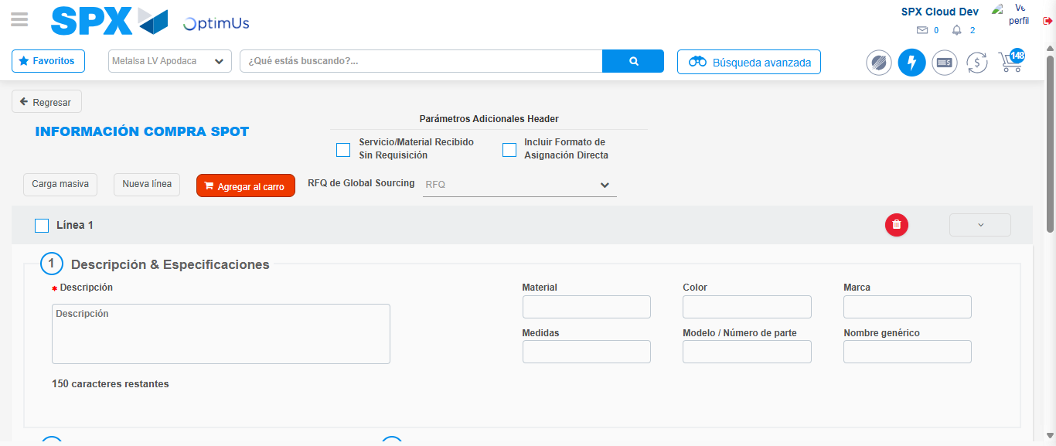Image file-name: QC_Testing-tc002_SPX_Dev5_Crear_Requisicion_Spot_Con_FAD_Tipo_Cobro_CC-1783355279013

Image file-name: QC_Testing-tc002_SPX_Dev5_Crear_Requisicion_Spot_Con_FAD_Tipo_Cobro_CC-1783355279173

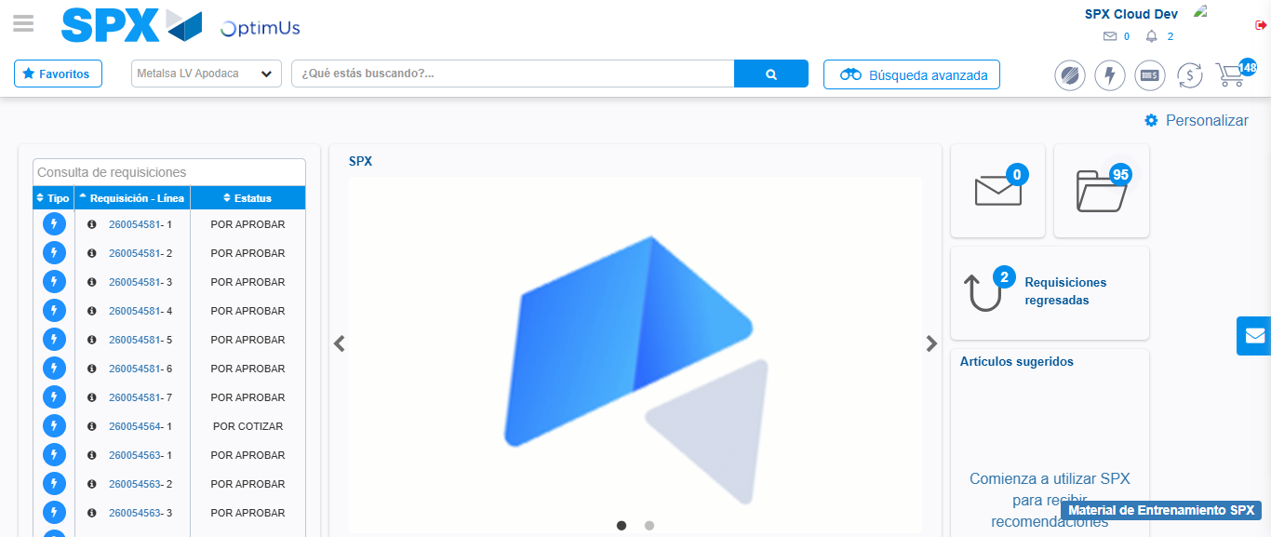Image file-name: QC_Testing-tc002_SPX_Dev5_Crear_Requisicion_Spot_Con_FAD_Tipo_Cobro_CC-1783355300329

Step 9 - Log Out : Log Out SPX
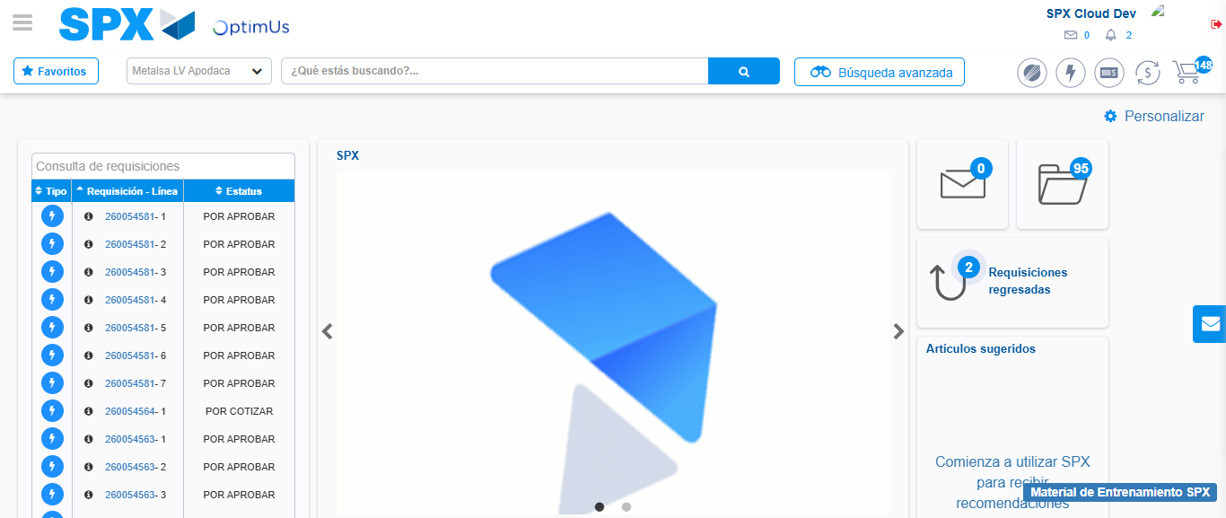Image file-name: QC_Testing-tc002_SPX_Dev5_Crear_Requisicion_Spot_Con_FAD_Tipo_Cobro_CC-1783355300645

